Week Five: Forum Theatre and Cardboard Citizens

Forum theater is an exercise in democracy in which anyone can speak and anyone can act. (Saxon)

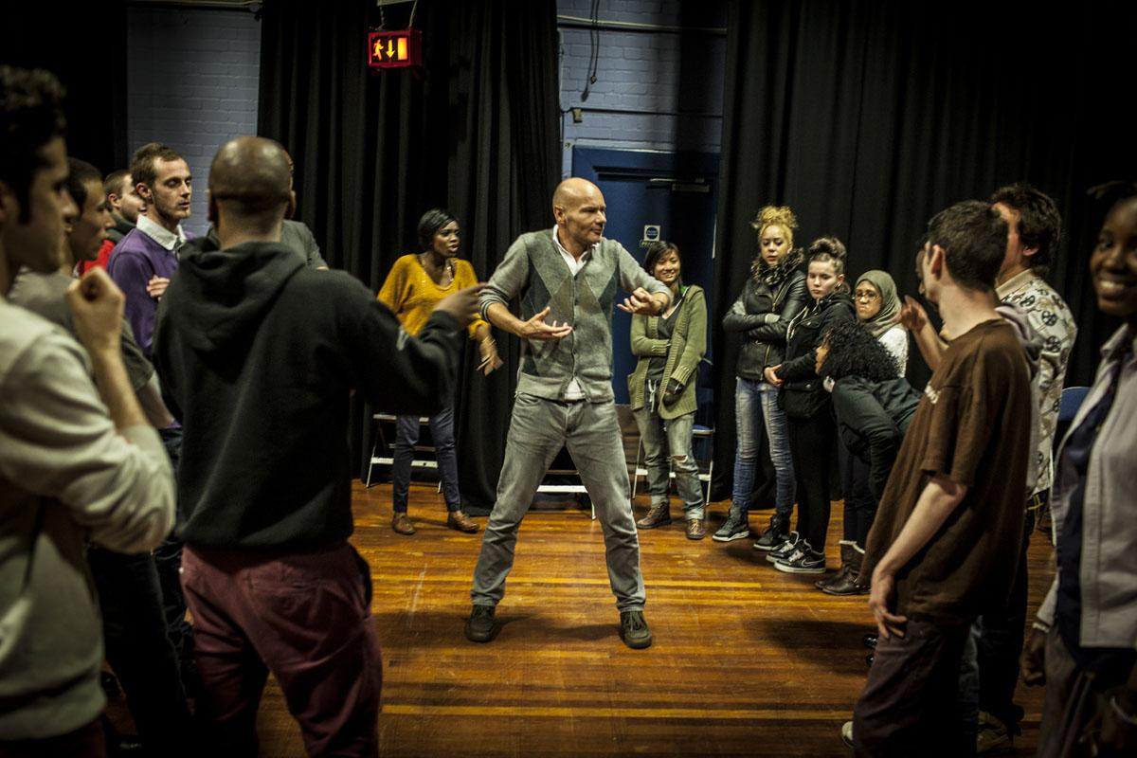

("Forum Theatre Tour | Cardboard Citizens")

Forum Theatre is one of the most famous elements of Theatre of the Oppressed, and one that is still commonly used in a wide range of displaced contexts today. Once such company using Forum Theatre to explore and challenge oppression is Cardboard Citizens. You will focus on the work of Cardboard Citizens for Task One, Part Two - when you will critique one or two of their Forum Theatre productions for Diii.

What is Forum Theatre? (20 minutes)

These three sources explain Forum Theatre succinctly.

https://beautifultrouble.org/tactic/forum-theater/
https://www.youtube.com/watch?v=mZLKHTfsgro
https://www.youtube.com/watch?v=9ZiWWTdKN98

Keep an eye out for these key terms whilst reading and watching. Make notes of any definitions. Remember to cite the sources.

Anti-model
Joker
Spect-actor
Magic solutions
Interventions

Exploratory task. (45 minutes including performances and Forum)
Evidence can be used for Bi, Ciii

Working in a small group (no more than three) devise a very short scene showing an issue of oppression; preferably one that you can all relate to, e.g. peer pressure, school pressure, bullying etc. This anti-model should last no more than two minutes, and must not have a clear resolution.

One of the group must also act as the ‘Joker’. In this practice task the role of the Joker is to introduce the performance and then facilitate the Forum; the post show discussion and direct interventions by the Spect-actors. The Joker must ensure there are no magic solutions presented during the interventions. The Oppressor cannot be replaced/changed, as that would be a magic solution in itself, instead the focus is on how the Oppressed could approach the situation in a different way. Or, as Adrian Jackson says, ‘what could they do differently that might get a better result?’

After you have performed make notes to explain what you have learned from this experience. How easy/hard was it to use Forum Theatre with the audience? What would you do differently next time? Insert videos/photos to illustrate. This work can be used for Bi, developing skills and Ciii, creative thinking.

Cardboard Citizens - Rehearsing Changes (15 minutes)
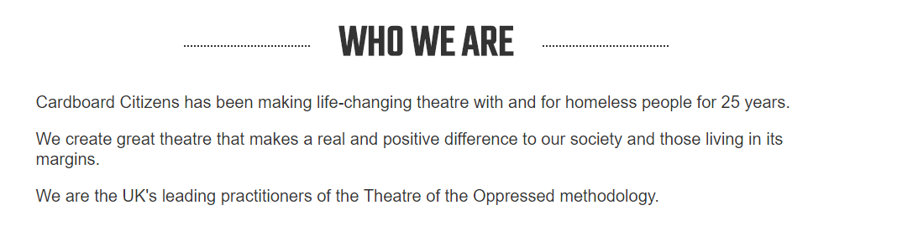
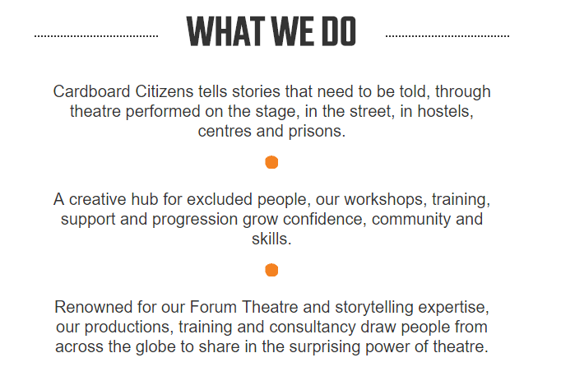
Spend 5 minutes exploring the Cardboard Citizens website to get a feel for their work. Then watch this short video.
Make any notes/insert key quotes here. You may also want to add any personal responses. Why is their work important? How can it help communities? Cite the sources.

Cardboard Citizens are well qualified to use Theatre of the Oppressed. The company’s founder, Adrian Jackson, worked very closely with Boal during his lifetime and was the official translator for the English language version of several of his books. The company hosted Boal on annual teaching visits for over ten years, right up until his death in 2009. Adrian Jackson often taught directly alongside Boal. ("Theatre Of The Oppressed | Cardboard Citizens")
If there is enough time left this week we will begin this task, if not we will work on it in Week 6.
For Task One, Part Two you will focus on the work of Cardboard Citizens, and critique one or more of their Forum Theatre performances for Diii.
We will watch Rising (written by Femi Keeling, directed by Stuart Mullin and performed by Cardboard Citizens) in class, starting today. This is a short interview with the director which provides some context.

https://twitter.com/LondonLive/status/1067429947176669184

You should make notes as you watch the performances. The written element of the task will be completed outside of class time. If you choose to focus on Cathy as well as/instead of Rising, you will need to watch that in your own time.

Rising:
https://www.london.gov.uk/cardboard-citizens-rising-2018-11-27
https://drive.google.com/file/d/1uvXLpNQEg9EbPSpWUyQOdtjQIqTY6HzR/view?usp=sharing

Anti-model (starts 21.14, ends 1.08)
Forum (starts 1.09, ends 1.42)
Post show Q&A (starts 1.42)

Cathy:
https://www.youtube.com/watch?v=Z-DbV3d-Nhs&feature=youtu.be

Notes:

