Task 2: Development consists of two sections, and is described as, ‘a selection of process journal extracts’

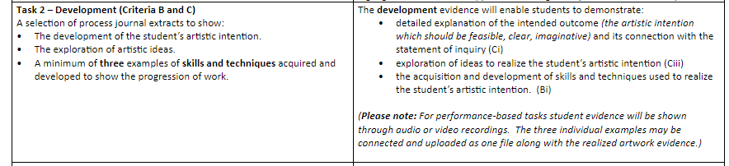

You have already completed Part 1: Artistic Intention. These instructions are for Part 2: Process Journal Extracts. Due 18th March

The selection of process journal extracts required for Part 2 must show evidence of:

- The ways in which you explored the ideas necessary to achieve your artistic intention (the creative thinking leading up to the performance, from the first group session right through to show day. How your AI changed over the rehearsals)

- How you acquired and developed at least three new performance specific skills and techniques that were necessary to achieve your artistic intention in performance.

Note that both sections clearly link to your Artistic Intention. You must relate back to your Artistic Intention wherever you can in your work for Process Work to score even a 3 or above.

Task Two: Development will be assessed against these strands:

Bi: the acquisition and development of skills and techniques used to realize the student’s artistic intention. (Bi)

Ci: detailed explanation of the intended outcome (the artistic intention which should be feasible, clear, imaginative) and its connection with the statement of inquiry (Ci)

Ciii: exploration of ideas to realize the student’s artistic intention (Ciii)

Note: You should begin to start planning your final portfolio around now. The maximums are below; use roughly equal space for each section. Be creative and use screenshots/images/designs and mind maps as well as paragraphs of text. You may need to do some careful editing of your work to cut it down; check with your teachers to see if there are any bits that can ‘go’ to create more space.

Task | Context | Example 1  6 mins video/18 A4 pages | Example 2  12 mins video/6 A4 pages
Task 1: Presentation | Research into Boal and Critique of Rising | 5 Pages | 3 pages
Task 2: Development | Artistic Intention and Process Journal Extracts, including video clips of skill development. | 2 mins video.  8 pages | 5 mins video.  1 page
Task 3: Outcome | Video of final performance | 4 mins video | 5 mins video
Task 4: Commentary | Self critique and response to the Unit Inquiry | 5 pages | 2 mins video  1 page

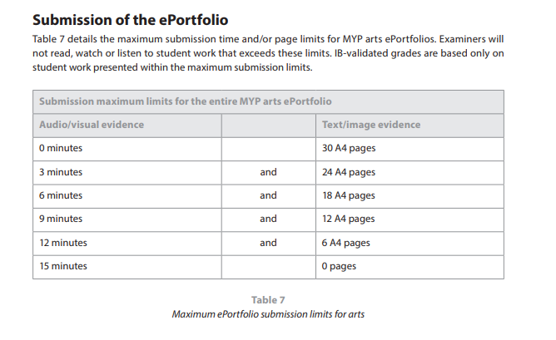
Ideas for entries

- Present and explain three different ideas you had for performance, then justify your final choice. Extension:relate this to the unit Inquiry
- Explanations of how and why your artistic intention changed during the rehearsals
- Screenshots of any designs/storyboards/mood-boards etc with justification/explanation
- Video clips of rehearsals, with explanation of what you want us to focus on and why. Should link to the AI
- Short video clips showing you learning and developing a performance skill or technique (remember you have to refer to at least 3 skills). Performance skills must link to the AI
- Video blogs live from the lesson
- Problems arising and how you solved them
- Extracts from interviews held with people related to your project, e.g. a class teacher or a friend who is advising you on content
- Explanation of how you and your group explored the starting point
- Video clips of work in progress including how you used feedback to develop your performance
- Research used to directly inform your production. Or any images/song lyrics etc that inspired you.
- Anything else you think is important/creative/relevant

Rubrics and Assessment Criteria

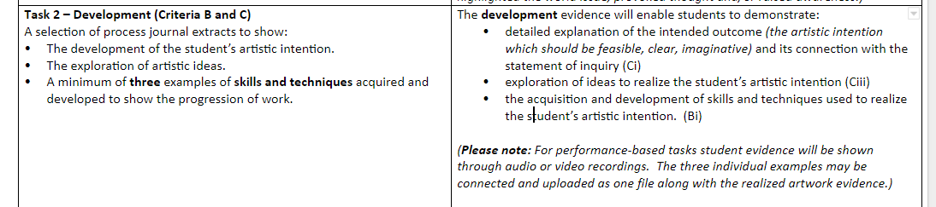

When you look at the assessment criteria you will notice that each band has a specific descriptor; limited (1-2), adequate (3-4), substantial (5-6) and excellent (7-8). These keywords are important.

Bi
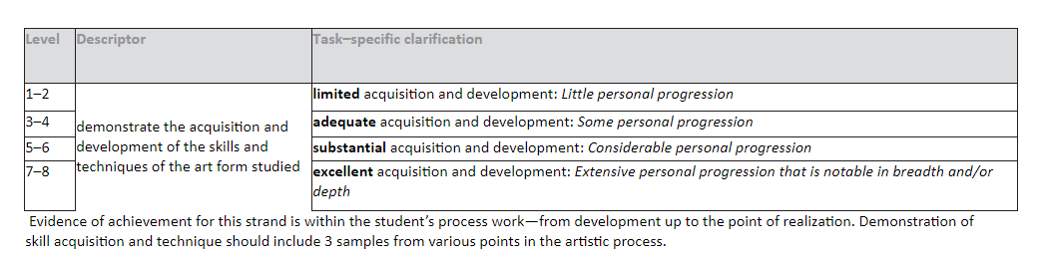

Cii
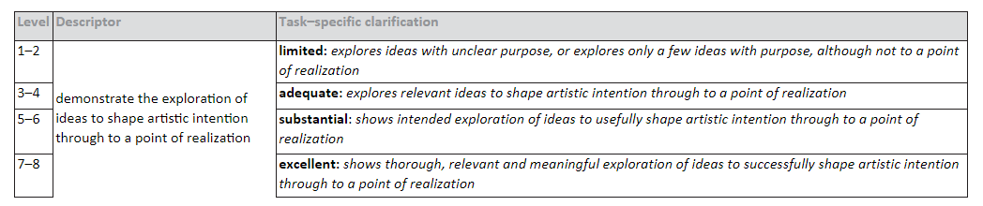

Criterion B – Developing skills
Strand i: demonstrate the acquisition and development of the skills and techniques of the art form studied
Criterion C – Thinking creatively
Strand iii: demonstrate the exploration of ideas to shape artistic intention through to a point of realization
1-2 | Bi. demonstrates limited acquisition and development of the skills and techniques of the art form studied | - You provide a list of the ways in which you acquired and developed two or three new skills and techniques related to Boal.  - You make limited connections between your Skill Development and your Artistic Intention  - There is limited evidence of personal progression.
 | Ciii. demonstrates limited exploration of ideas to shape artistic intention that may reach a point of realization. | - You list your exploration of ideas.  - You make limited links between these explorations and your Artistic Intention.  - The purpose of your explorations are often unclear and they have little impact on the development of the final performance.
3-4 | Bi. demonstrates adequate acquisition and development of the skills and techniques of the art form studied | - You provide a clear overview of the ways in which you acquired and developed three new skills and techniques related to Boal.  - You make adequate connections between your Skill Development and your Artistic Intention  - There is some evidence of personal progression.
 | Ciii. demonstrates adequate exploration of ideas to shape artistic intention through to a point of realization | - You outline your exploration of ideas.  - You make some links between these explorations and your Artistic Intention.  - The purpose of your explorations are clear and relevant and they have an impact on the development of the final performance.
5-6 | Bi. demonstrates substantial acquisition and development of the skills and techniques of the art form studied | - You provide a clear description of the ways in which you acquired and developed three new skills and techniques related to Boal.  - You make substantial connections between your Skill Development and your Artistic Intention  - There is clear evidence of considerable personal progression
 | Ciii. demonstrates substantial exploration of ideas to purposefully shape artistic intention through to a point of realization. | - You describe your exploration of ideas in detail.  - You make clear and meaningful links between these explorations and your Artistic Intention.  - The purpose of your explorations are clear and relevant and they have an important impact on the development of the final performance.
7-8 | Bi. demonstrates excellent acquisition and development of the skills and techniques of the art form studied | - You provide a clear explanation of the ways in which you acquired and developed three new skills and techniques related to Boal.  - You make excellent connections between your Skill Development and your Artistic Intention  - There is detailed evidence of extensive personal progression that is notable in breadth and/or depth
 | Ciii. demonstrates excellent exploration of ideas to effectively shape artistic intention through to a point of realization. | - You explain your exploration of ideas in relevant and meaningful depth.  - You make thorough and meaningful links between these explorations and your Artistic Intention.  - The purpose of your explorations are clear and relevant and they have an essential impact on the development of the final performance.

