Week 8 - Artistic Intentions

Task Two: Development consists of several sections, one of which is the Artistic Intention, assessed for Ci. The IBO instructions state that you must provide a, ‘detailed explanation of the intended outcome (the artistic intention which should be feasible, clear, imaginative) and it’s connection to the statement of inquiry’

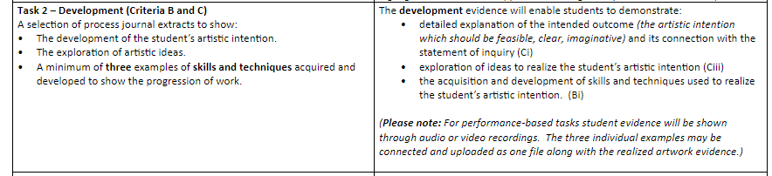

This week you will work on your Artistic Intentions, both a formative group statement and a summative individual statement. The individual statement will be assessed for Ci. You will receive three lessons to complete the task, and will upload it at the end of the third lesson. (5B and 5C - 31st Jan) But, it is important to understand that this Artistic Intention will develop even further as time passes and the IBO expect to see explicit evidence of these developments in your later/other work submitted for Task Two.

You should already have a clear idea as to who your target audience is, and what your main ideas are for a performance that highlights a world issue, provokes thought and/or raises awareness.

Now you need to refine these fabulous ideas and concepts into a group statement of Artistic Intention (formative) and an individual statement of Artistic Intention (summative).

First we’ll read this example and then you will be able to start working on the tasks as listed below.

Artistic Intentions - Planning and Activity Sheet
15  minutes | Read and discuss/make notes  - Check the Inquiry for the unit. Your Artistic Intention MUST relate directly to Statement of Inquiry ‘Art has the power to impact the world’ and the Global Context of Fairness and Development to score above a 2. It’s best to write your statement with specific reference to the Key Concept, Related Concept etc as well.  - Use these power words and phrases to inspire you  - Use the learner profile to help you focus your responses.  - Use the example for added guidance
45 mins | Draft and refine your group AI.  - It should be a concise, coherent and exciting statement, that uses a range of power words and key phrases, and relates clearly to the Inquiry for this unit.  - Read the statement aloud to check its ‘flow’ and ensure you’ve made a connection to the Statement of Inquiry!  - Create individual copies of this document and add the group statement to yours.
90  minutes | Add your individual artistic intention for assessment, basing it on your the group statement.  - Any time left over can be used for refining Task One, Part Two or journal work.

Rubrics and Assessment Criteria

When you look at the assessment criteria you will notice that each band has a specific descriptor; limited (1-2), adequate (3-4), substantial (5-6) and excellent (7-8). These keywords are important.

The IBO have defined each as follows for Ci:

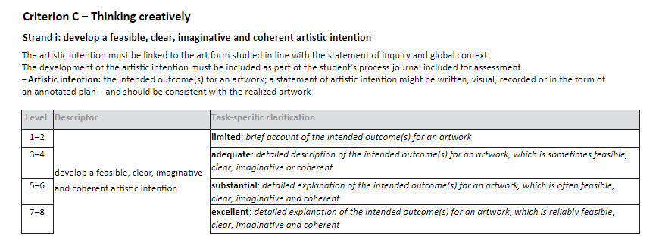

Ci - Develops a feasible, clear, imaginative and coherent artistic intention
1-2 | Ci) develops a limited artistic intention that is rarely feasible, clear, imaginative or coherent | - You provide a brief account of the intended outcomes for your performance. This account is often unclear/lacks imagination and creativity, or is unfeasible.  - You make a very limited link with the Statement of Inquiry and/or Global Context for the unit in your Artistic Intention.
3-4 | Ci) develops an adequate artistic intention that is occasionally feasible, clear, imaginative and/or coherent | - You provide an outline with some description of the intended outcomes for your performance. This account is sometimes clear, feasible, imaginative or coherent  - You make an adequate link with the Statement of Inquiry and/or Global Context for the unit in your Artistic Intention.
5-6 | Ci) develops a substantial artistic intention that is often feasible, clear, imaginative and coherent | - You provide a detailed description with some explanation of the intended outcomes for your performance. This account is often clear, feasible, imaginative or coherent  - You make a substantial link with the Statement of Inquiry and/or Global Context for the unit in your Artistic Intention.
7-8 | i) develops an excellent artistic intention that is consistently feasible, clear, imaginative and coherent | - You provide a detailed explanation of the intended outcomes for your performance. This account is reliably clear, feasible, imaginative or coherent  - You make an excellent link with the Statement of Inquiry and/or Global Context for the unit in your Artistic Intention.

