MYP5 Drama: Artists Make a Difference

Last week we explored the Inquiry for this unit:

Statement of Inquiry | Art has the power to impact the world
Key Concept | Change
Related Concept | Expression
Global Context | Fairness and Development
Inquiry Questions | Factual: What events have changed the world?  Which events/periods in time have been documented through art?  Which artists have impacted the world through their art?  Conceptual: How do artists impact humankind and the environment?  To what extent does art motivate society from thinking into doing?  Debatable: Can the emotional response to art be as significant when the art is about an issue or event that the audience has not experienced?
Learner Profile | Principled. Communicator. Risk Taker (courageous)
ATL’s | Communication: Interpret and use effectively modes of non verbal communication.  Social: Exercise leadership and take on a variety of roles within groups

We also explored how might artists make a difference/impact the world.

By Communicating a message
Raising awareness
Making a social and/or political statement through art
Encouraging self reflection and action
Promoting open mindedness and tolerance
Pushing for peace
Commenting directly on an event or local/global issue
Empowering an individual or community, giving them a voice.
Generating a strong emotional response/impact in an audience
Motivating action within a community/group of people
Protesting against a person, group, government etc through art
Bringing attention to something
Imagining a hopeful future
Confronting power and privilege

You explored some issues that shaped the world in relation to Fairness and Development and then listed some drama skills that you could use in a short performance designed to communicate a message. You then performed your scene, gathered feedback and began to complete some initial research to help develop your work further. These were the tasks.

Activities - Week Two

Task One: Applying research and feedback (45 minutes)
After completing your research and reflecting on the feedback from the first showings of your scenes, spend some time restructuring your performance to make it more impactful. Decide on a short AI to help guide you. Try to use your research to help you integrate techniques such as audience interaction, use of (reliable) statistics and media/music. Get feedback on your new, improved version.

Make any planning notes here

Task Two - Fairness and Development. Oppressed and Oppressor 10 minutes

The global context for this unit is Fairness and Development.

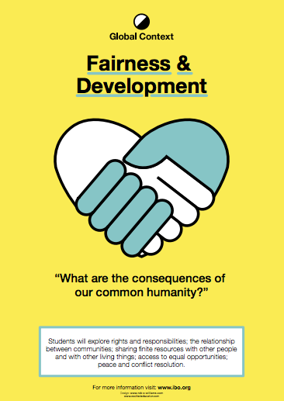
https://www.excitededucator.com/2014/09/the-next-chapter-myp-global-context.html

One access point for the exploration of Fairness and Development is the concept of OPPRESSION. For oppression to occur there must be an OPPRESSOR (person or group) and an OPPRESSED (person/group/species etc).

Complete this form with a partner.
Rights and responsibilities:
Possible issues to explore:Voting rights, equal opportunities, access to education, access to food, water, shelter. Responsibilities as ‘citizens’ and as humans.????
Oppressors: Governments, big corporations, religious groups????
Oppressed: Communities, gender groups, religious groups, ethnic groups ???
The relationship between communities
Possible issues:War, boundary disputes, ethnic segregation
Oppressors:
Oppressed:
Sharing resources with other people and living things
Possible issues: Deforestation, global warming, refugees
Oppressors:
Oppressed:
Access to equal opportunities
Possible issues: Healthcare, education
Oppressors:
Oppressed:
Conflict resolution
Possible issues: Equal representation, the rights of others, intercultural understanding
Oppressors:
Oppressed:

Task Three - Showing ‘the Oppressed and the Oppressor’ 10 minutes

Choose three of the issues you have explored above and create THREE still images that clearly show the Oppressor and the Oppressed in each situation. Think carefully about how you can use levels, eye contact, proxemics and other techniques to represent your character and situation.

Take a photo of each still image and insert them here, with some brief notes to explain what you are showing, how and why.

