MYP5 Drama: Artists Make a Difference

In MYP Arts, ‘Artist’ is an umbrella term covering all forms of creative expression. An actor is an artist, as is a designer, a director, a theorist or anybody else involved in creating performance work. A musician is also an artist, as is a composer, or a designer, or a painter etc. Art and artwork are also umbrella terms, and can mean performance, music, visual art, photography, design, dance etc.

How might artists make a difference?

By Communicating a message
Raising awareness
Making a social and/or political statement through art
Encouraging self reflection and action
Promoting open mindedness and tolerance
Pushing for peace
Commenting directly on an event or local/global issue
Empowering an individual or community, giving them a voice.
Generating a strong emotional response/impact in an audience
Motivating action within a community/group of people
Protesting against a person, group, government etc through art
Bringing attention to something
Imagining a hopeful future
Confronting power and privilege
?
?
?

Example One: Photography

This famous photo brought world attention to the events happening in China at the time of the ‘Tiananmen Square Massacre’. You can read more about Tank Man here.

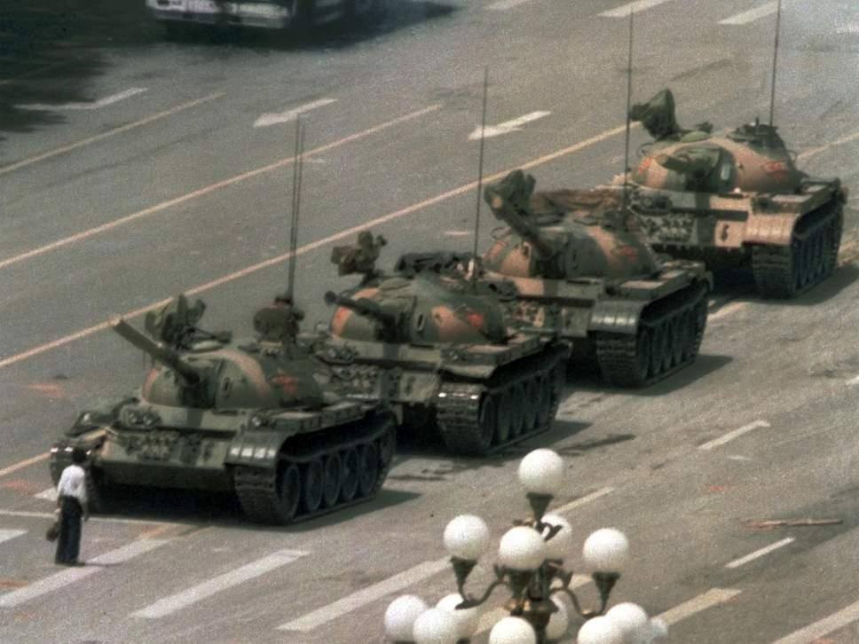

‘The image of Tank Man quickly became a powerful symbol of both the bloody events of 4 June 1989 and of non-violent resistance, but the identity of the ‘unknown rebel’ and his fate remains unknown.’ ("Tiananmen Square 25Th Anniversary: What Happened To Tank Man?")

Example Two: Music/Video

https://www.youtube.com/watch?time_continue=140&v=wEBlaMOmKV4

‘The 1960s were a significant period for artists, with the civil rights movement defining much of what was happening in the media. Out of this time comes one of the most famous protest songs – Sam Cooke’s ‘A Change Is Gonna Come’. Living as a black man in 1960s America, Cooke was no stranger to racism and after being turned away from a whites-only motel in Louisiana, he felt compelled to write about the struggles of African Americans’. ("A Brief History Of Protest Songs")

Example Three: Performance

https://youtu.be/IbmprCvrJOA (start at 1.36)

The Cost of Living is a famous piece by DV8, an innovative fully inclusive physical theatre company. The piece is a comment on British society that challenges and shocks. ("DV8’S Incredible Dance Film ‘The Cost Of Living’")

Think, Pair, Share

What are some of the events that have shaped the world? (Inquiry Question) Can you think of any real world examples of art that has made/is making a difference? Can you think of a piece of art that has had an impact on you?

Art has the power to impact the world

How can we make a difference through Drama?

The unit title is ‘Artists Make a Difference’ and the Statement of Inquiry is ‘Art has the power to impact the world’. You have started to explore some of the ways in which other artists have made a difference and impacted the world through their work.

The practical outcome for this unit will be a performance, ‘intended to make a difference because it highlights a world issue, provokes thought and/or raises awareness’ (resources.ibo.org)

With that in mind, can you already think of any skills and techniques you could use? Do you know about any theatre practitioners that have impacted the world in this way through their work?

Make some notes here:

Fairness and Development

The Global Context for this unit is Fairness and Development

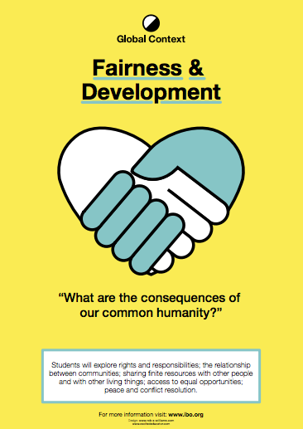
https://www.excitededucator.com/2014/09/the-next-chapter-myp-global-context.html

As you already know, the performance you create for assessment must be, ‘intended to make a difference because it highlights a world issue, provokes thought and/or raises awareness’ (resources.ibo.org)

These world issues could include (but are not limited to) conflict, cultural tolerance, environmental waste, drought, famine, gender equality, natural or manmade disasters, political asylum, racism, refugees.’ (resources.ibo.org)

Are there any global or local issues related to Fairness and Development that you would particularly like to focus on? Make notes on any initial ideas, including the impact you might want to make or a message that you would like to communicate? You could also insert any images/links that inspire you, but don’t forget to cite the source.

Connections

The Learner Profile attributes for this unit are:

Principled
We act with integrity and honesty, with a strong sense of fairness and justice, and with respect for the dignity and rights of people everywhere. We take responsibility for our actions and their consequences.

Communicators
We express ourselves condently and creatively in more than one language and in many ways. We collaborate effectively, listening carefully to the perspectives of other individuals and groups.

Risk Takers
We approach uncertainty with forethought and determination; we work independently and cooperatively to explore new ideas and innovative strategies. We are resourceful and resilient in the face of challenges and change.

("Managebac")

The ATLS for the unit are:

Communication skills
Exchanging thoughts, messages and information effectively through interaction
→Interpret and use effectively modes of non-verbal communication

Collaboration skills
Working effectively with others
→Exercise leadership and take on a variety of roles within group work

("Managebac")

Inquiry through Action

Devising task: 45 minutes to prepare

Choose one of these starting points

https://centrepoint.org.uk/youth-homelessness/

https://www.childline.org.uk/info-advice/bullying-abuse-safety/your-rights/child-refugees-and-asylum-seekers/

https://youngminds.org.uk/find-help/feelings-and-symptoms/bullying/

Working in a group of between 2 and 5, develop a short performance (max 3 mins) developed from your chosen starting point. The play should ‘make a difference’ in some way, so think about how you can creatively communicate a message and have some form of impact on the audience. Some of these techniques might be worth experimenting with. Don’t stereotype or make fun of your issue. Be principled.

Once you have performed use audience feedback to help you gauge how clearly you communicated your message and how effective the impact on the audience was. Make notes so you can use them to help you in the next performance task.

Inquiry through Research

There are lots of terms used to describe theatre that makes a difference, including Protest Theatre, Theatre for Change, Issue Based Drama and Applied Theatre. There are also many important practitioners and companies who have made an impact through their work, including Augusto Boal, whose work will be the main focus of your study this unit.

Research and share (45 minutes)

In small groups research your allocated areas and prepare to share 5-8 key findings about each with the class.

Group One:
Theatre in Education/Issue Based Drama
https://www.bbc.com/bitesize/guides/zsbjn39/revision/3
https://www.wearegibber.com/blog/what-is-theatre-in-education/

Applied Theatre/Theatre for Development/Participatory Theatre
http://steinhardt.nyu.edu/music/edtheatre/programs/appliedtheatre
http://dictionary.tdf.org/applied-theatre/
http://participatesdgs.org/methods/theatre-development-tfd/
https://www.youtube.com/watch?v=ph7_nJP5MQs&t=6s

Group Two:
Political Theatre/Protest Theatre
http://www.dramaonlinelibrary.com/genres/political-theatre-iid-2514
http://brooklynrail.org/2008/09/theater/the-power-of-political-theater
http://www.pahnation.com/what-is-protest-theatre/

Epic Theatre
http://www.thedramateacher.com/epic-theatre-conventions/
https://www.bbc.co.uk/education/guides/zwmvd2p/revision

Group Three:
Theatre of the Oppressed http://www.mandalaforchange.com/applied-theatre/theatre-of-the-oppressed/
https://www.theguardian.com/culture/2002/jul/24/artsfeatures
Invisible and Guerilla Theatre
http://beautifultrouble.org/tactic/invisible-theater/
https://sites.google.com/site/boaltpjctsd13/invisible-theatre
https://study.com/academy/lesson/guerrilla-theatre-definition-examples.html

Use this research to reflect back on your own performance and how you could have developed it.

Make some notes here, including ideas for ‘making a difference’ inspired by your research.

