Last week we inquired into the Global Context of Fairness and Development through the focal point of the Oppressed and the Oppressor. This week you will develop these explorations through research and practical work.

So what is Theatre of the Oppressed? (20 minutes)

We will be focusing on the work of a very important practitioner for this unit - Augusto Boal. You can truly say that Boal’s work ‘made a difference’ and ‘impacted the world’.

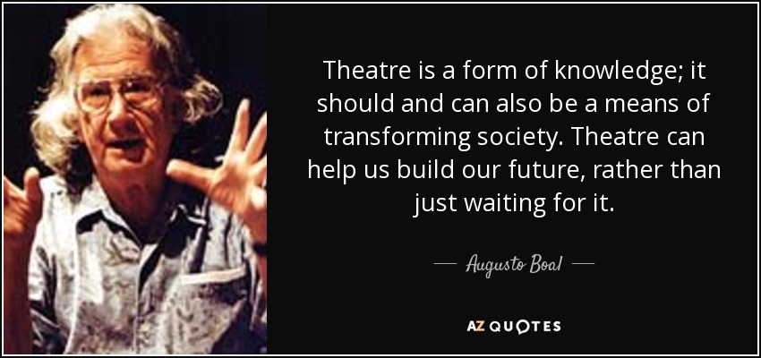
("TOP 17 QUOTES BY AUGUSTO BOAL | A-Z Quotes")

Boal is primarily recognised for his work in developing Theatre of the Oppressed, a range of techniques and strategies through which the actors and audience are empowered to make a change in their lives. Prep for S1 - Research

https://www.youtube.com/watch?v=HOgv91qQyJc (part one)
https://www.youtube.com/watch?v=p7F7H9ejM6E (part two)

Make notes on the video here, including anything that has particular meaning for you and anything that makes you wonder why, how or when.

Home Learning: Read this document, written by Jenny Whittaker, originally published in Style Tasters. Prep for S1 - Research.

https://docs.google.com/document/d/1QQrjciQ6l6sWFS3PRhVu_HpsmzSq11wK6NYd8oBBXlw/edit?usp=sharing

I have highlighted many key points in blue for you to focus on primarily, but make notes below to record anything else important, relevant and interesting

Task Two - Games For Actors and Non Actors (15 minutes including game play)

Boal believed that games were necessary to build relationships and trust between group members at the start of any ToP session. The games were also used as an important element in training the body for acting by developing flexibility, strength and posture and also in improving self expression. Read the following synopses of four of Boal’s games. Which skills is he looking to develop through each exercise?

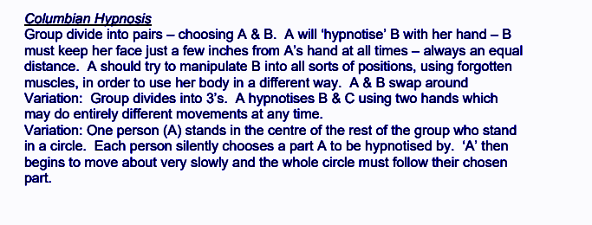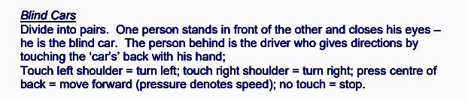
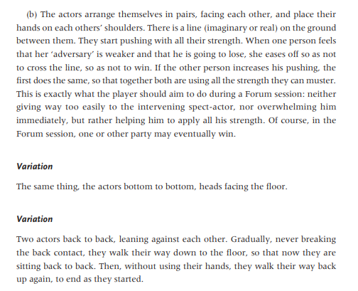

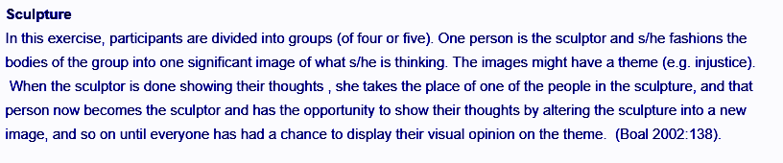

http://handbook.actvise.eu/?page_id=115

After completing the Sculpture game insert some photos of the still images here, adding any relevant notes. Prep for Task 2 - Development

