Week Four - Image Theatre (90 minutes) and Invisible Theatre (30 minutes)

Prep for Task 2 - Development, Task 3 - Product and Task 4 - Commentary

In Image Theatre you explore issues of oppression through still images that show emotions, ideas, concepts, events and/or issues. These might be 'sculpted' by an individual or created as a group, as you just experienced in the previous activity. These still images can then provide a starting point for discussion that explores possible solutions and actions. The still images can also be dynamised (brought to life.)

'The idea underlying Image Theatre is that a picture paints a thousand words and that our over-reliance on words can confuse or muddle issues rather than clarify them.' https://fyi100.files.wordpress.com/2013/10/boal_reading_2.pdf

‘In Image Theatre, still images are used to explore abstract concepts such as relationships and emotions, as well as realistic situations. This technique was developed by Augusto Boal and is described fully in his book The Rainbow of Desire’ https://dramaresource.com/image-theatre/

‘Image theater, a social change tool developed by Augusto Boal, is one of the more widely used forms of Theater of the Oppressed, in which activists, students or any group are invited to form statues that represent a moment in time of an oppressive situation. The image can then serve as a springboard for critical group reflection in order to both understand the situation better and to try out possible “solutions’ https://beautifultrouble.org/tactic/image-theater/

The following two images have been selected in line with the United Nations Universal Declaration of Human Rights. The United Nations (UN) came into being in 1945, shortly after the end of World War II. The stated purpose of the UN is to bring peace to all nations of the world. ("Youth For Human Rights Educational Organization, Tours, Events, Materials")

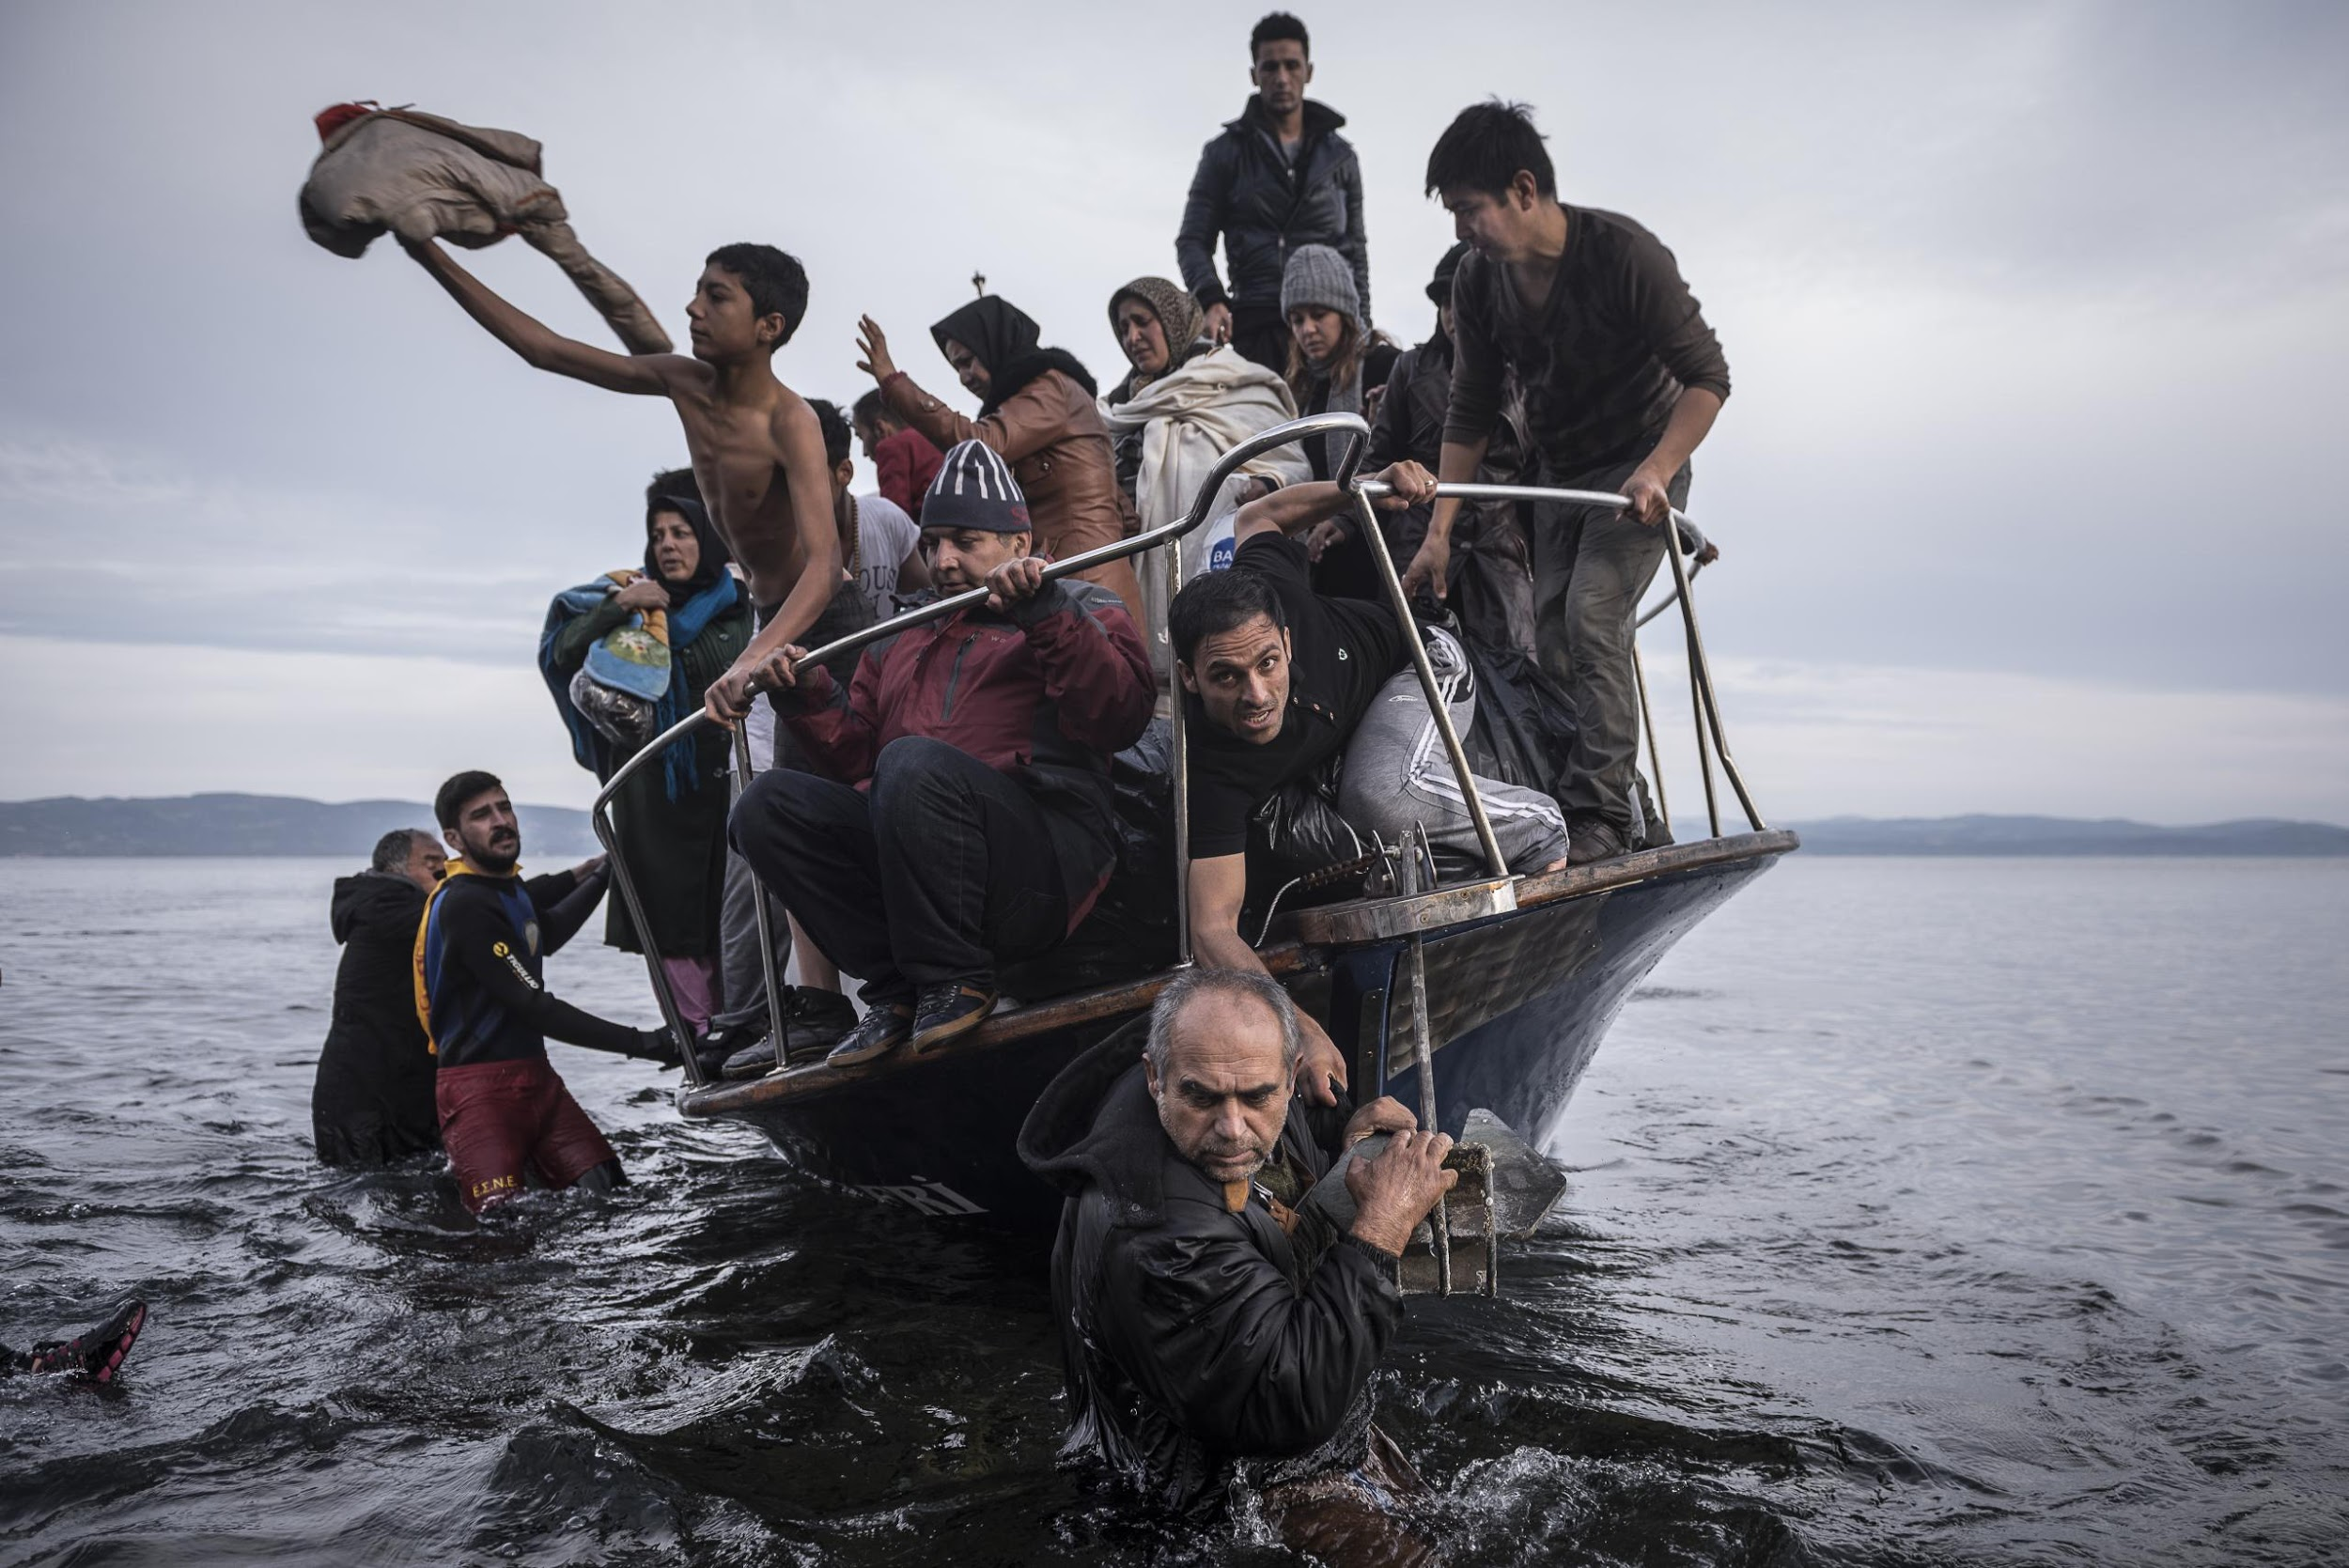

Image source: https://www.worldpressphoto.org/collection/photo/2016/general-news/sergey-ponomarev

1,We Are All Born Free & Equal.
We are all born free. We all have our own thoughts and ideas. We should all be treated in the same way.

3. The Right to Life.
We all have the right to life, and to live in freedom and safety.

14. The Right to Seek a Safe Place to Live.
If we are frightened of being badly treated in our own country, we all have the right to run away to another country to be safe.

28. A Fair and Free World.
There must be proper order so we can all enjoy rights and freedoms in our
own country and all over the world.

("Articles 1-30, United Nations Declaration Of Human Rights : Youth For Human Rights Video")

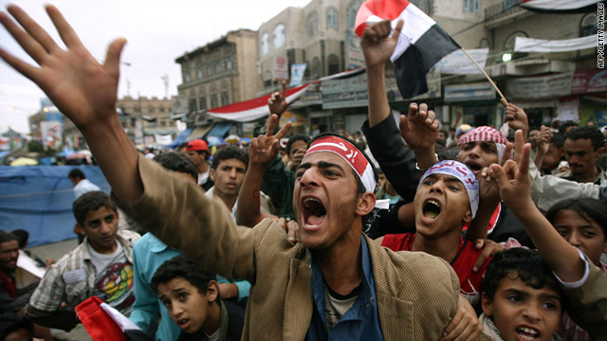

Image source: http://edition.cnn.com/2011/WORLD/meast/04/25/voices.arab.future/index.html

1. We Are All Born Free & Equal. We are all born free. We all have our own thoughts and ideas. We should all be treated in the same way.

2. Don’t Discriminate. These rights belong to everybody, whatever our differences.

18. Freedom of Thought. We all have the right to believe in what we want to believe, to have a religion, or to change it if we want.

19. Freedom of Expression. We all have the right to make up our own minds, to think what we like, to say what we think, and to share our ideas with other people.

20. The Right to Public Assembly. We all have the right to meet our friends and to work together in peace to defend our rights. Nobody can make us join a group if we don’t want to.

21. The Right to Democracy. We all have the right to take part in the government of our country. Every grown-up should be allowed to choose their own leaders.

28. A Fair and Free World. There must be proper order so we can all enjoy rights and freedoms in our own country and all over the world.

("Articles 1-30, United Nations Declaration Of Human Rights : Youth For Human Rights Video")

Performance Task

Working in groups of 4-6 choose one of the images.

Think/discuss: Who can you see? Where is the photo taken? Who is in shot? How might these people be feeling? What might have happened to them? What words might sum the photo up? You can follow the links given above to find out the ‘real’ story behind the photos if you’re interested in the context.

Recreate: Try to recreate the image as best you can. Get someone from another group to take a photo of your still image and compare it to the original. Have you captured the emotions of the photo? Are you showing how your character feels? Use levels, proxemics etc

Create: Now create a still image of your own that represents ‘the refugee crisis’ or some form of protest. Take a photo to check that you are using levels effectively and that everyone can be seen. Make any changes needed. You will show these to the class for feedback.

Develop/devise: After showing your first still image and getting feedback, your group needs to create a further three, all focused on the ‘refugee crisis’ or the concept of Protest,. You may want to look online for inspiration.

Link/Perform: Once you have your four still images you need to find a way of linking these into one performance; by transitioning smoothly from one to the next. Put all four together to make a short performance. Include appropriate music/signs/media. You can dynamise the images (bring them ‘to life’), use some dialogue, show comparison images of what actually is and what the solution could be, use projections etc.

Examples of Image Theatre from Ms Hull’s classes in a previous school

https://www.youtube.com/watch?time_continue=1&v=e_MhHQaJqp4 (not perfect but gives some ideas. Note - you should hold the still images much longer, at least 5 seconds))

Record: Record your performance and insert the link and any screenshots of key moment here. Add notes to explain how you

- Acquired and developed new skills in Image Theatre (Bi)
- Used creative thinking skills to explore alternatives, different perspectives and solve problems. (Ciii)

Note: You could write about this activity for Task Two: Process. You would need to explain clearly how you acquired (gained) and developed new performances skills and techniques in Image Theatre, so make sure you keep a record of your work.

Invisible Theatre - 30 minutes

You may already have come across the term Invisible Theatre whilst researching Boal’s Theatre of the Oppressed.

Creative Thinking Task (Cii, Ciii)

Prep for Task Two - Development

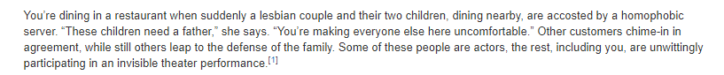

The quote above comes from this website:

https://beautifultrouble.org/tactic/invisible-theater/

Skim read the article, making a note of key points.

Working in groups of 3-4 write proposals for two different (and contrasting) invisible theatre pieces that could be performed in the school or local community.

Points to consider:

- What issue are you raising awareness of?
- Why have you chosen this issue?
- Where will the scene take place?
- Who are the target audience and why?
- Why would the issue be relevant/important to this audience?
- What is the main artistic intention/message?
- How will you make people believe they are watching ‘reality’?
- How will you deal with it if you trigger someone, someone gets really angry or something else goes wrong?
- Who would need to be aware it was a piece of theatre/give permission for the scene to be performed?

